MEDIA ALERT:
THE RAZER VIPER MINI – CONCENTRATED VENOM

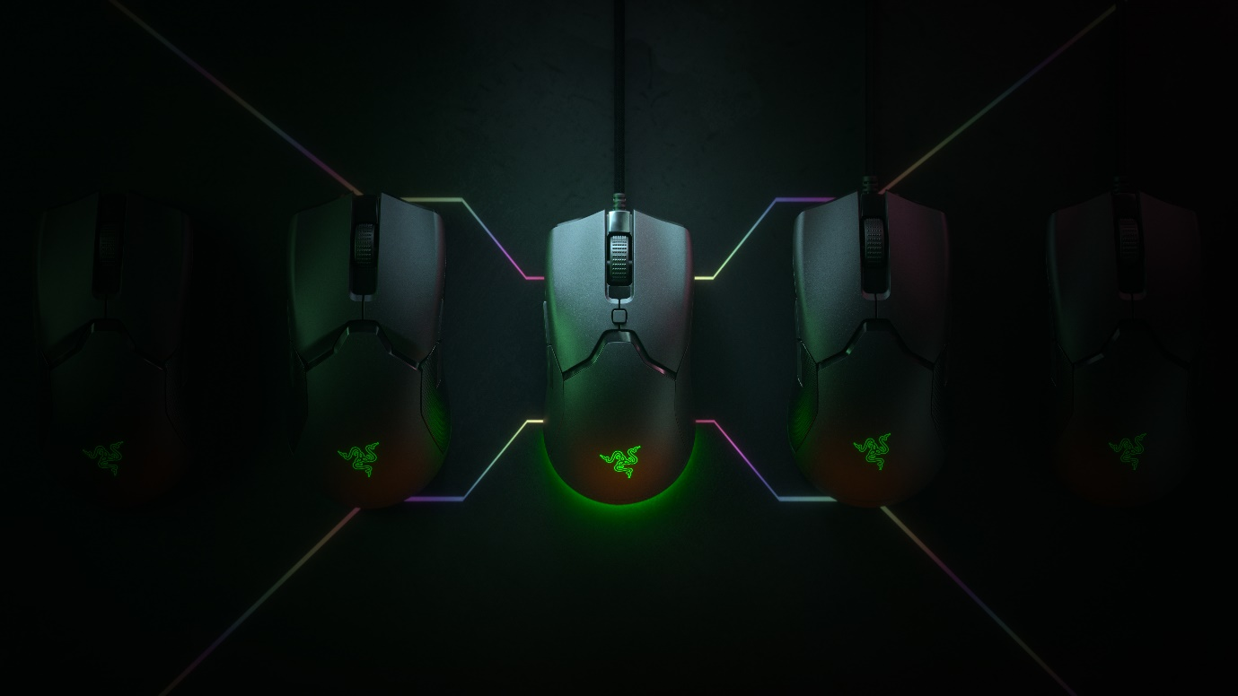
For Release on March 4th, 2020 at 8am PT / 5pm CET / 23.59pm SGT
WHO: Razer, the leading global lifestyle brand for gamers.
WHAT: The Razer Viper Mini is the latest addition to the popular Viper range of gaming mice from Razer, packing many of the award-winning technologies of the full-sized Razer Viper into a compact chassis, ideal for smaller hands. The Viper Mini is Razer’s lightest mouse yet, weighing in at just 61g, almost half the weight of the average gaming mouse.
Featuring the same ambidextrous design and ergonomics as the critically acclaimed Razer Viper, the new Viper Mini is fitted with Razer Optical Mouse Switches and six programmable buttons. It boasts an 8,500 DPI sensor with 300 IPS tracking, for sharp, responsive, pixel-precise accuracy in-game.
With Razer Chroma™ RGB Underglow lighting and on-board memory profile storage, the Viper Mini is perfect for gamers looking for an ultra-lightweight, smaller form-factor mouse, without compromising on performance or features.
For more information and the specifications on the Razer Viper Mini, please check here.
WHY: The new Razer Viper Mini, a smaller version of the fan-favourite Razer Viper, is perfect for gamers with small to medium hands or those looking for a feature-rich, high-performance mouse in a lighter, more portable chassis.
WHEN: March 4th, 8am PT / 5pm CET / 23.59pm SGT
PRICE: $39.99 USD / 49.99€ MSRP
WHERE: Razer.com and authorized retailers
ASSETS: Please see here.

ABOUT RAZER
Razer™ is the world’s leading lifestyle brand for gamers.
The triple-headed snake trademark of Razer is one of the most recognized logos in the global gaming and esports communities. With a fan base that spans every continent, the company has designed and built the world’s largest gamer-focused ecosystem of hardware, software and services.
Razer’s award-winning hardware includes high-performance gaming peripherals and Blade gaming laptops.
Razer’s software platform, with over 70 million users, includes Razer Synapse (an Internet of Things platform), Razer Chroma (a proprietary RGB lighting technology system), and Razer Cortex (a game optimizer and launcher).
In services, Razer Gold is one of the world’s largest virtual credit services for gamers, and Razer Fintech is one of the largest online-to-offline digital payment networks in SE Asia.
Founded in 2005 and dual-headquartered in Irvine and Singapore, Razer has 16 offices worldwide and is recognized as the leading brand for gamers in the USA, Europe and China.
Razer is listed on the Hong Kong Stock Exchange (Stock Code: 1337).

PRESS CONTACTS
Americas
Kham Lam
Kham.Lam@razer.com
EMEA
Maren Epping
Maren.Epping@razer.com
China
Evita Zhang
Evita.Zhang@razer.com
Asia Pacific
Vanessa Li
Vanessa.Li@razer.com
Global
Jan Horak
Jan.Horak@razer.com
Razer - For Gamers. By Gamers.™
# # #

